Virginia States University
Department of Engineering and Computer Science
ENGR 102-01 – Introduction to Engineering (Fall 2020)

Date:
Chapter 7 HW: Fluid Mechanics

On my honor, I have neither given nor received any unauthorized aid on this homework, and I pledge that I am in compliance with the VSU Honor System.

Print Name Signature

Instructions: Show your work to get full credit; partial credit will be given where appropriate. Start your solution by identifying the appropriate equation (s).

- The specific gravity of a liquid is 0.920. Find the density and specific weight of the liquid in SI and English units. (10 points)
Let x = unknown density
y = unknown specific weight
Sg = specific gravity = 0.920
Density of Water ρ(water) = 1000 kg/m³(SI Unit) = 1.940 slugs/ft³ (English Unit)
SI Units
Density of Unknown Liquid
x = Sg * ρ(water) = 0.920(1000 kg/m³) = 920 kg/m³
English Units.
x = Sg * ρ(water) = 0.920(1.940 slugs/ft³) = 1.78 slugs/ft³
Specific Weight of Water
λ(water) = 9.810 kN/m³ (SI Unit) = 62.4 lb/ft³ (English Unit)
Specific Weight of Unknown Liquid
SI Units
y = Sg * λ(water) = 0.920(9.810 kN/m³) = 9.02 kN/m³
English Units
y = Sg * λ(water) = 0.920(62.4 lb/ft³) = 9.02 kN/m³ = 57.408 kN/m³

- A 12-cm diameter cylindrical can is filled to a depth of 10 cm with motor oil (ρ=878 kg/m³). Find the mass and weight of the motor oil. (10 points)
r = radius = 6cm
h = height = 10cm
V = Volume = $πr^{2}h= π*6^{2}*10=1130.97 cm^{3}$
M = p* v = 0.878 g/cm³* $1130.97 cm^{3}=992.9946 g=0.993 kg$
W = mass * gravity = 0.993 kg * 9.81 = 9.7413 N
Mass = 0.993kg
Weight = 9.7413 N

- Find the volume of mercury (sg = 13.55) that weighs the same as 0.04 m³ of ethyl alcohol (sg = 0.802) (5 points)
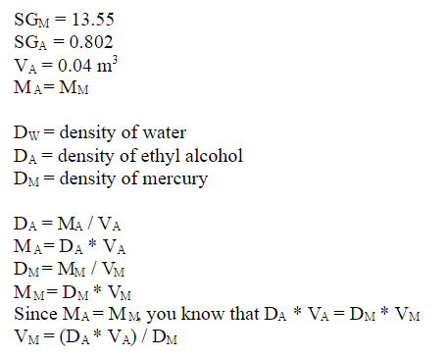
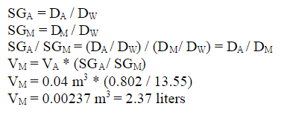
- Find the pressure change required to produce a 1.90 percent decrease in the volume of benzene at 20°C. (5 points)

Bulk modulus of water (k) is 2×10⁹N/m²
$\frac{∆P}{k}=\frac{∆V}{V}$
$∆P=1.9\%*k$ = 0.019 * 2×10⁹N/m² = 3.8 ×10⁷ N/m²
$∆P=$3.8 ×10⁷ N/m²

- What is the percent change in the volume of a liquid whose bulk modulus value is 100 times the change in pressure? (5 points)
$∆P=x$
Bulk module = 100 x
$\frac{∆P}{k}=\frac{∆V}{V}$
$\frac{x}{100x}=\frac{∆V}{V}$
Percent change in the volume = $\frac{x}{100x}*100\%=1\%$

- A storage tank containing heavy fuel oil (ρ=906 kg/m³) is filled to a depth of 5 m. Find the gauge pressure at the bottom of the tank. (5 points)
Pressure = density * height* gravity
$ΔP = γ h = ρ g h$
= 906 kg/m³*5 m * 9.81 m/sec² = 44,439.3 Pa
= 44,439.3 Pa
- The deepest known point in the oceans of the earth is the Mariana Trench, east of the Philippines, with a depth of approximately 10.9 km. Taking the specific gravity of seawater as sg = 1.030, what is the pressure at the bottom of the Mariana Trench? Express your answer in kPa, psi and atmospheres. (10 points)

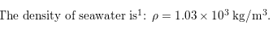
Patm = 1.013 * 10⁵Pa
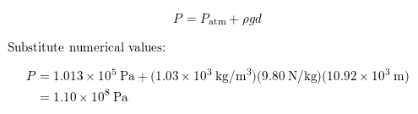
P = 1.10 * 10⁸ kPa
1 Pascal = 0.00014503773 Psi.
1.10 * 10⁸ Pa = 15954.151 Psi
1atm = 1.01325 * 10⁵Pa
1.10 * 10⁸ Pa = $\frac{1.10 * {10}^{8}Pa *1atm}{1.01325 * {10}^{5}Pa}$ = 1085.6 atm
P = 1.10 * 10⁸ kPa
= 15954.151 Psi
= 1085.6 atm

- The side of a barge is submerged 6 m below the surface of the ocean (γ=10.1 kN/m³). The length of the barge is 90 m. Treating the side of the barge as a plane vertical surface, what is the total force exerted by the ocean on the side of the barge? (10 points)

$F_{R}= γ h A/2$
h = 6m
L = 90m
W = 6m
F_{R}= 10.1 kN/m³* 6m *90m* 6m* 0.5 = 16,362 kN
Total force exerted by the ocean on the side of the barge = 16,362 kN

- A glass tube carries mercury at an average velocity of 30 cm/s. If the inside diameter of the tube is 4.0 mm, find the volume flow rate and the mass flow rate. (10 points)
Volume flow rate = Area * Average Velocity
Mass flow rate = mass / unit time
4 mm = 0.4cm
Area = $\frac{π*{0.4}^{2}}{4}$ = 0.1256 cm²
Volume flow rate = 0.1256 cm²* 30 cm/s = 3.77 cm³/s
Density for mercury = 13.6 g/cm³
Mass flow rate = Volume flow rate * Density for mercury
= 3.77 cm³/s * 13.6 g/cm³= 51.272 g/cm³
Volume flow rate =3.77 cm³/s
Mass flow rate = 51.272 g/cm³

- A furnace requires 1250 lb_{m} /h of cold air for efficient combustion. If the air has a specific weight of 0.064 lb_{f}/ft³, find the required volume flow rate. (10 points)

Volume flow rate = Area * Average Velocity
Mass flow rate -= 1250 lb_{m} /h
1 lb_{m} /h = 0.000125998 kg/s
1250 lb_{m} /h = 0.1575 kg/s

specific weight = 0.064 lb_{f}/ft³

1 lb_{f}/ft³ = 16.0185 Kg/ m³
0.064 lb_{f}/ft³= 1.025 kg/ m³
^{Volume flow rate =} $\frac{Mass flow rate}{Density}$
$\frac{0.1575 kg/s }{1.025 kg/m^{3}}= \frac{0.1575 m^{3}}{1.025s}$ ^{= 0.153} m³/s
Volume flow rate = 0.153 m³/s

- A nozzle is a device that accelerates the flow of a fluid. A circular nozzle that converges from an inside diameter of 5 cm to 3.5 cm carries a gas at a volume flow rate of 0.10 m³/s. find the change in average velocity of the gas. (10 points)
5cm = 0.05 m
35cm = 0.35m
Volume flow rate = Area * Average Velocity
Average velocity in 5 cm pipe
0.10 m³/s = $\frac{π*{0.05}^{2}}{4}$ * V1
V1 = 50.93 m/s
Average velocity in 3.5 cm Pipe
0.10 m³/s = $\frac{π*{0.035}^{2}}{4}$ * V2
V2 = 103.94 m/s
Change in average velocity = V2- V1
= 103.94 – 50.93 = 53.01m/s
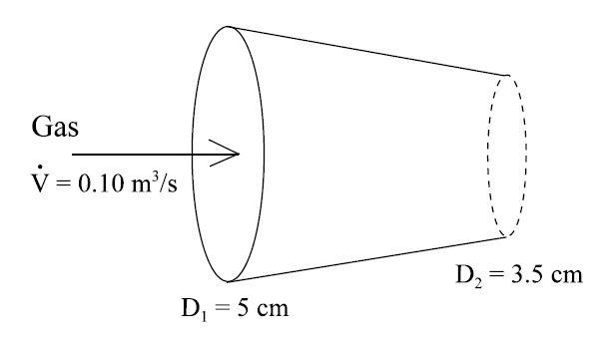

- A pipe branch is illustrated in schematic form below. Find the mass flow rate${\dot{ m}}_{4}$. Does the fluid in branch 4 enter or leave the junction.

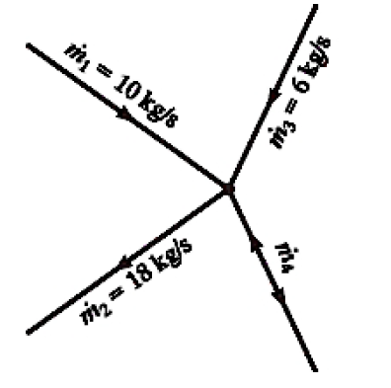
Incoming fluid = outgoing fluid
M1 + M3 + M4 = M2
10 +6 +m4 = 18
M4 = 18 – 16 = 2
M4 = 2Kg/s
Positive sign of M4 shows that the fluid in the branch 4 will be entering the junction.

Useful Equations and Equivalence Statements

- $ρ=\frac{m}{V}$
- $W=mg$
- $γ=\frac{W}{V}$
- $γ=ρg$
- $sg=\frac{ρ_{fluid}}{{ρH}_{2}O, 4℃}$ ${ρH}_{2}O, 4℃=1000 kg/m^{3}$
- $sg=\frac{γ_{fluid}}{{γH}_{2}O, 4℃}$ ${γH}_{2}O, 4℃=9810 N/m^{3}$
- $K=\frac{-∆P}{∆V/V}$
- $ΔP = γ h$
- $ΔP = γ h = ρ g h$
- $F_{R}= γ h A/2$
- $z_{cp} = h/3$
- $\dot{}=vA$
- $\dot{m}=ρV$
- $\dot{V} = v A = v π D^{2}/4$
- $\dot{m}={sg}_{Hg}ρ_{H_{2}O}\dot{V}$
- 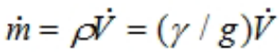
- $v = \dot{V}/A = \frac{ \dot{V}}{WH}$
- $v_{1}/v_{2} = (\dot{V}/A_{1})/(\dot{V}/A_{2}) = A_{2}/A_{1} = {(D_{2}/D_{1})}^{2}$
- 
 